Spatial machine learning in R
prof. dr hab. Katarzyna Kopczewska

Class 13: Measuring spatial agglomeration
Updated: 12.04.2026

Spis treści
1. Starter & problems to solve 2
2. ETA (Entropy-Tesselation-Agglomeration) 3
2.1 ETA agglomeration by sectors – in a for() loop 7
3. SPAG – Index of spatial agglomeration 9
3.1 SPAG agglomeration by sectors – in a for() loop 10

Starter & problems to solve

- We want to detect agglomeration – high density in some places and low density in other places
- We want to assess the degree of agglomeration - for how much the data are agglomerated or dispersed
- We want to get one number as a measure of density
- We want to express the degree of agglomeration as a divergence from the uniform spatial distribution

What we want to do?
ETA | SPAG
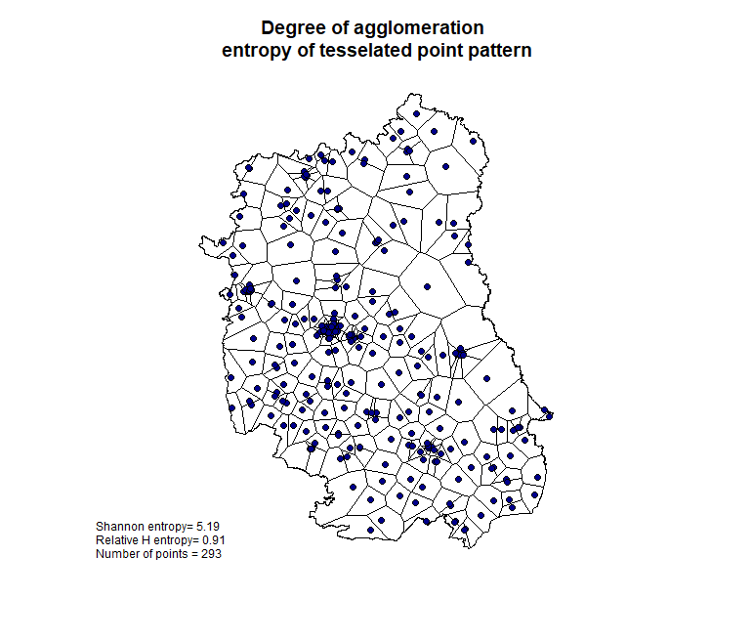 | 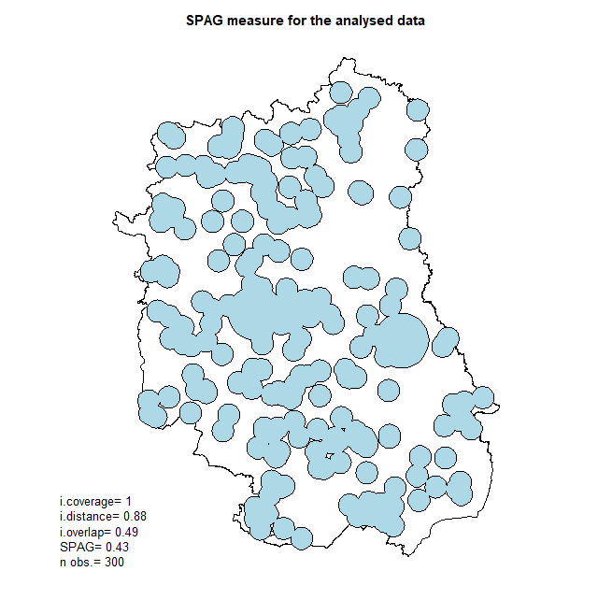

# starter

# use starter for reading data from class 5
# and here below are extra codes

packageinstall.packages("devtools") # to install from Github
devtools::install_github("poktam/spatialWarsaw")
library(spatialWarsaw)

ETA (Entropy-Tesselation-Agglomeration)

Agglomeration - the inequality in spatial distribution, can be captured well with the statistical methods that are designed to discover imbalances, for example with entropy. Entropy is called a measure of disorder, which is equivalent to randomness or uncertainty. High entropy means high uncertainty. In spatial terms it is understood as spatially uniform distribution – if all locations appear with the same frequency, one cannot guess what will be the most probable location. This yields high uncertainty and in mathematical terms, it is the randomness of location (when all places are equally probable). The highest entropy is typical for grid division. Oppositely, low entropy means no uncertainty or, in other words, one can easily guess the outcome. In spatial terms it appears in the case of high concentration – if the majority of observations locates in a given place, one can assume other observations also go there.

Entropy H operates on probabilities p – shares that sum up to 100% and is expressed as follows:
$$H=-\sum{p∙log⁡(p)}$$
An issue of how to switch from point pattern to probabilities p can be solved with tessellation based on Voronoi polygons. For each set of geo-located points within a given area (region), one can derive tessellation – a continuous division of this territory into tiles. The total area of all tiles equals the area of the territory. Therefore, one can get the shares of tiles in a whole territory – they play the role of probabilities p. Shares of tiles in case of uniform distribution are approximately equal – like in a grid division. This makes the entropy value high. Shares of tiles in case of agglomeration are diversified – bigger in areas with fewer points and smaller in areas with more points – this makes the entropy values low.

The maximum entropy can be calculated from perfectly spatially uniform distribution or derived using the general formula:
$$H_{max}=-n∙p_{i}∙\log\left(p_{i}\right)=-n∙\frac{1}{n}∙\log\left(\frac{1}{n}\right)=-log⁡(\frac{1}{n})$$

The most useful approach in measuring the agglomeration is a comparison of maximum (hypothetical) entropy with the observed one, known as the relative entropy H_{rel}:
$$H_{rel}=H_{empir}/H_{max}$$
$$H_{rel}=\frac{H_{empir}}{H_{max}}=-\sum_{i=1}^{n}{p_{i}*\log\left(p_{i}\right)} /-log⁡(\frac{1}{n})$$
This evidences what is the deviance of a given point pattern from the uniform one. The more similar the empirical and theoretical values of entropy, the more uniform (and less agglomerated) distribution is. On the other hand, the bigger difference between those two, the stronger the agglomeration.

# construction of measure
# tesselation of theoretical patterns
# build a poligon of side 1 - this is a box
polygon<-st_sfc(st_polygon(list(cbind(c(0,1,1,0,0),c(0,0,1,1,0)))))
plot(st_geometry(polygon))
axis(1)
axis(2)

#####################################
# STOP AND CHOOSE
# point patter: random / regular / hexagonal distribution
my.points<-st_sample(polygon, 15, type="random")
my.points<-st_sample(polygon, 15, type="regular")
my.points<-st_sample(polygon, 15, type="hexagonal")

# ALTERNATIVE for clustered pattern
points.clust<-data.frame(X=rnorm(15, mean=0.5, sd=0.07), Y=rnorm(15, mean=0.5, sd=0.07))
my.points<-st_as_sf(points.clust, coords=c("X", "Y")) #

#####################################
# plot generated points
plot(st_geometry(polygon))
axis(1)
axis(2)
plot(st_geometry(my.points), add=TRUE)

# for any pattern in sf - Voronoi tesselation
points.sfc<-st_geometry(my.points)
box.sfc<-st_geometry(polygon)
points.union<-st_union(points.sfc)
tess<-st_voronoi(points.union, box.sfc)
tess.clip<-st_intersection(st_cast(tess), st_union(box.sfc))

# properties of tessellation tiles and entropy
a<-st_area(tess.clip)
a1<-a/sum(a)
ent1<-sum(-1*a1*log(a1))
ent1
n<-length(a)
ent.ref<-log(1/n)*(-1)
ent.ref
ent.rel<-ent1/ent.ref # Relative H
ent.rel

# plot – with points in blue
par(mar=c(4,4,4,4))
plot(st_geometry(tess.clip), main="Degree of agglomeration
entropy of tesselated random point pattern", sub="Relative H entropy =1 for spatially uniform distribution (no agglomeration)")
plot(st_geometry(points.sfc), add=TRUE, bg="darkblue", pch=21)
axis(1)
axis(2)
legend(0.001, 0.99, horiz=FALSE, c(paste("Shannon H =", round(ent1,2)), paste("Relative H =", round(ent.rel,2)), paste("N =", round(n,2))), cex=0.75, bty="n")

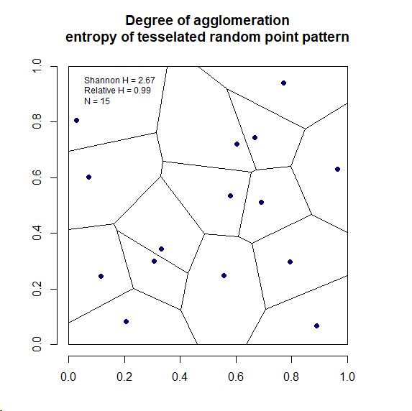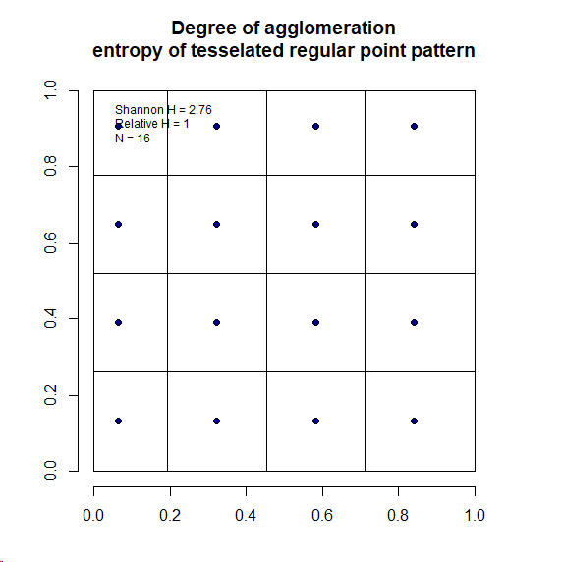
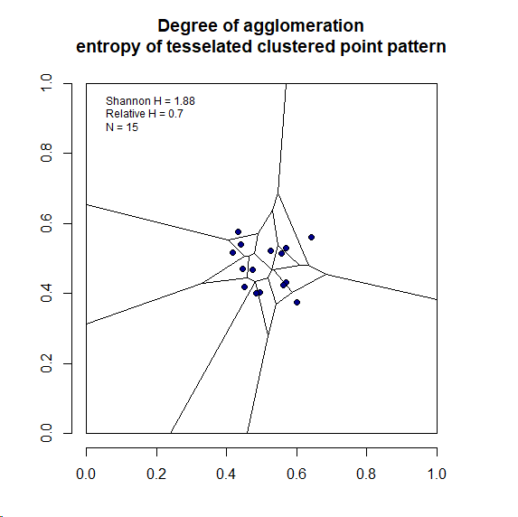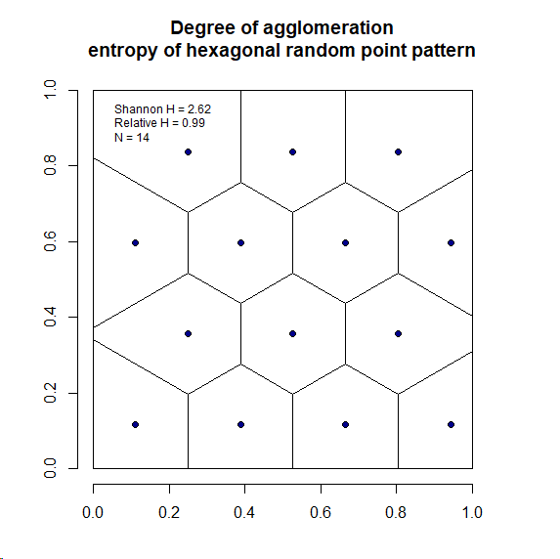
ETA (as Relative H) is 0.99 for random and hexagonal distributions, 1.00 for regular distribution and 0.7 for clustered pattern.

# automated solution - for empirical data

library(spatialWarsaw)
selector<-sample(1:dim(firms)[1], 300, replace=FALSE)
firms.sf.lim<-firms.sf[selector, ]
my.eta<-ETA(firms.sf.lim, region.voi, 300) # from spatialWarsaw::

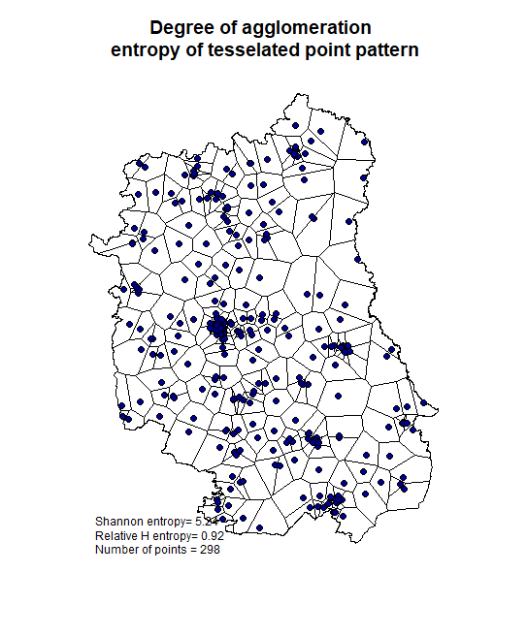

2.1 ETA agglomeration by sectors – in a for() loop

# sectoral agglomeration

tabela<-table(firms$SEC_PKD7) # table of number of firms by sectors
sectors<-names(tabela)

tabela
A B C D E F G H I J K L M
20863 16 1374 41 61 2031 4772 1186 421 392 481 528 1341
N O P Q R S
376 234 645 1027 316 1268

sectors
[1] "A" "B" "C" "D" "E" "F" "G" "H" "I" "J" "K" "L" "M" "N" "O" "P" "Q" "R" "S"

n<-length(sectors) # how many sectors
eta.sectors<-matrix(0, nrow=n, ncol=4) # object for loop
colnames(eta.sectors)<-c("industry", "Shannon", "H relative", "n_obs")

for(i in 1:n){ # start of the loop
sec<-sectors[i] # select sector name
my.eta<-ETA(firms.sf[firms.sf$SEC_PKD7==sec,], region.voi, 500)
eta.sectors[i,1]<-sec
eta.sectors[i,2]<-my.eta$S_ent
eta.sectors[i,3]<-my.eta$H_ent
eta.sectors[i,4]<-my.eta$n_points } # save results

eta.sectors<-as.data.frame(eta.sectors)
eta.sectors[, 2:4]<-apply(eta.sectors[, 2:4], 2, as.numeric)
eta.sectors
industry Shannon H relative n_obs
1 A 5.904622 0.9583547 474
2 B 2.406371 0.8679148 16
3 C 5.392829 0.8798800 459
4 D 2.816244 0.8643833 26
5 E 3.544776 0.9312030 45
6 F 5.510900 0.8923282 481
7 G 5.283589 0.8566802 477
8 H 5.345278 0.8781791 440
9 I 5.018924 0.8584583 346
10 J 4.655727 0.8120443 309
11 K 4.946637 0.8357367 372
12 L 4.809996 0.8352280 317
13 M 4.833933 0.7965712 432
14 N 5.002998 0.8677939 319
15 O 5.105121 0.9555974 209
16 P 5.299094 0.8779903 418
17 Q 4.930463 0.8112460 436
18 R 4.983935 0.8926191 266
19 S 5.246545 0.8581646 452

# plot ETA by sectors
plot(eta.sectors[,3], type="l", ylim=c(0.75,1), axes=FALSE, xlab="", ylab="") # line chart
points(eta.sectors[,3], pch=21, bg="deeppink3", cex=1.6) # points
axis(1, at=1:n, labels=sectors, cex.axis=0.7) # x axis
axis(2) # y axis
text(1:n, eta.sectors[,3]+0.01, sectors) # text next to points
abline(h=0:10*0.1, lty=3, col="grey80") # horizontal lines
title(main="ETA by sectors") # title

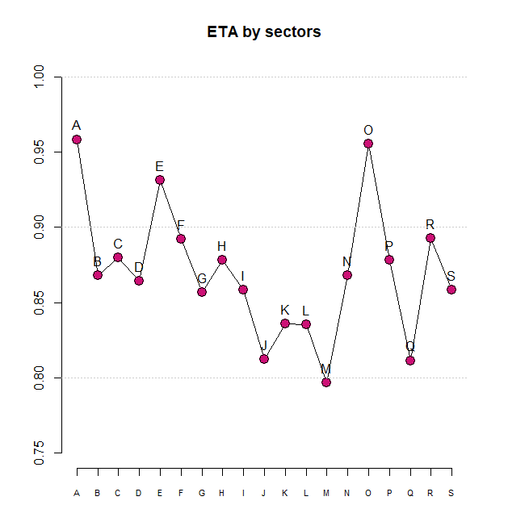

3. SPAG – Index of spatial agglomeration

SPAG index (Spatial Agglomeration index) (Kopczewska et al., 2019, Kopczewska, 2025) is a measure that captures and compares the spatial distribution of firms with regard to their size. It is derived as a product of two sub-indices (both scaled [0,1]):
- distance index that compares empirical average distance between firms to the hypothetical average distance of equally distributed firms, and
- overlap index that builds the circles proportional to size of firms and checks for how much they overlap and not cover the space.
The intuition is that for firms extremely concentrated in one place, the average distance is much shorter than in equal distribution and circles representing firms overlap, instead of covering the whole territory, so the proportion of covered territory is small. Multiplication of both indices gives the value of SPAG – the degree of spatial agglomeration – the lower the value the stronger the spatial concertation in one place. SPAG is scaled between [0,1] and therefore fully comparable across time, regions and sectors.
An important element of the metric is the size of firms – it assumes inherently that big firms impact wider territory than small firms and their spatial range affects more small firms located around. This feature allows for separating the effects of ‘big firms’ in agglomeration process. One can apply synthetic-SPAG approach by comparing real SPAG with hypothetical SPAG which assumes firms of equal size. Difference, mostly in overlap index, show the importance of size of firm for the degree of agglomeration. Comparing size-sensitive and equal-size SPAG enables identification of anchor-firm effects within clusters. A lower SPAG under equal-size assumptions suggests that large firms amplify spatial overlap and act as spatial organizers of cluster structure.

library(spatialWarsaw)
firms.sf$empl<-round(firms.sf$empl_av_size, 0)
selector<-sample(1:dim(firms)[1], 300, replace=FALSE)
firms.sf.lim<-firms.sf[selector, ]

my.spag<-SPAG(firms.sf.lim, "empl", region.voi) # from spatialWarsaw::
my.spag



3.1 SPAG agglomeration by sectors – in a for() loop

# sectoral agglomeration

tabela<-table(firms$SEC_PKD7) # table of number of firms by sectors
sectors<-names(tabela)

tabela
A B C D E F G H I J K L M
20863 16 1374 41 61 2031 4772 1186 421 392 481 528 1341
N O P Q R S
376 234 645 1027 316 1268

sectors
[1] "A" "B" "C" "D" "E" "F" "G" "H" "I" "J" "K" "L" "M" "N" "O" "P" "Q" "R" "S"

n<-length(sectors) # how many sectors
SPAG.sectors<-matrix(0, nrow=n, ncol=5) # object for loop
colnames(SPAG.sectors)<-c("industry", "I_overlap", "I_dist", "SPAG", "n_obs")

for(i in 1:n){ # start of the loop
sec<-sectors[i] # select sector name
my.SPAG<-SPAG(firms.sf[firms.sf$SEC_PKD7==sec,], "empl", region.voi)
SPAG.sectors[i,1]<-sec
SPAG.sectors[i,2]<-my.SPAG$i.overlap
SPAG.sectors[i,3]<-my.SPAG$i.distance
SPAG.sectors[i,4]<-my.SPAG$SPAG
SPAG.sectors[i,5]<-my.SPAG$n.obs } # save results

SPAG.sectors<-as.data.frame(SPAG.sectors)
SPAG.sectors[, 2:4]<-apply(SPAG.sectors[, 2:5], 2, as.numeric)
SPAG.sectors
industry I_overlap I_dist SPAG n_obs
1 A 0.2978675 0.9185123 0.2735950 20863
2 B 0.9429553 0.7364902 0.6944774 16
3 C 0.4066348 0.7640863 0.3107041 1374
4 D 0.3572101 0.6743545 0.2408862 41
5 E 0.4088334 1.0541209 0.4309598 61
6 F 0.3558025 0.8801722 0.3131674 2031
7 G 0.2224737 0.8436913 0.1876992 4772
8 H 0.3097738 0.8521761 0.2639819 1186
9 I 0.2769514 0.8250757 0.2285058 421
10 J 0.2345969 0.6196350 0.1453645 392
11 K 0.3274373 0.7506684 0.2457969 481
12 L 0.2329123 0.7452798 0.1735848 528
13 M 0.2284169 0.7069441 0.1614780 1341
14 N 0.3794692 0.7789153 0.2955744 376
15 O 0.5232671 0.9318249 0.4875933 234
16 P 0.3230440 0.8633990 0.2789159 645
17 Q 0.3016846 0.7084945 0.2137419 1027
18 R 0.4007558 0.8133714 0.3259633 316
19 S 0.2550494 0.7717109 0.1968244 1268

# line plot of SPAG by sector
plot(SPAG.sectors[,4], type="l", ylim=c(0,1))
points(SPAG.sectors[,4], pch=21, bg="grey35", cex=1.6)
text(1:n, SPAG.sectors[,4]+0.05, sectors)
abline(h=0:10*0.1, lty=3, col="grey60", lwd=2)
legend(5, 0.9, legend=c("SPAG"), lty=c(1), lwd=c(1), pch=21, pt.bg=c("grey35"), bty="n")

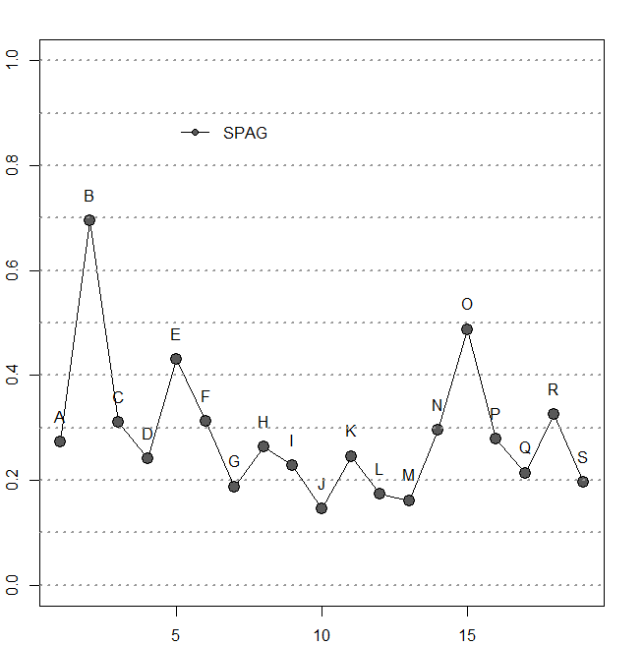

# line plot of SPAG components by sector
plot(SPAG.sectors[,3], type="l", ylim=c(0,1.1))
points(SPAG.sectors[,3], pch=21, bg="grey80", cex=1.6)
lines(SPAG.sectors[,2])
points(SPAG.sectors[,2], pch=21, bg="grey50", cex=1.6)
text(1:21, SPAG.sectors[,3]+0.05, sectors)
text(1:21, SPAG.sectors[,2]-0.05, sectors)
abline(h=0:100*0.1, lty=3, col="grey60", lwd=2)
legend(8, 1.05, legend=c("distance index", "overlap index"), lty=c(1,1), lwd=c(1,1), pch=21, pt.bg=c("grey80", "grey50"), bty="n")

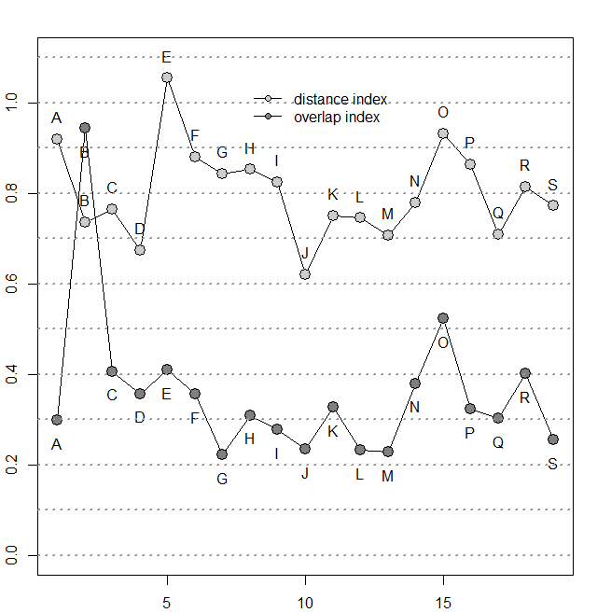
i=1
sec<-sectors[i] # select sector name
my.SPAG<-SPAG(firms.sf[firms.sf$SEC_PKD7==sec,], "empl", region.voi)

i=13
sec<-sectors[i] # select sector name
my.SPAG<-SPAG(firms.sf[firms.sf$SEC_PKD7==sec,], "empl", region.voi)

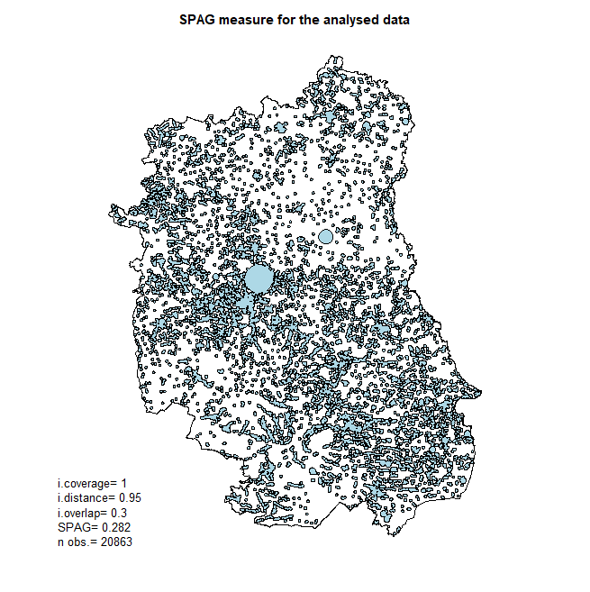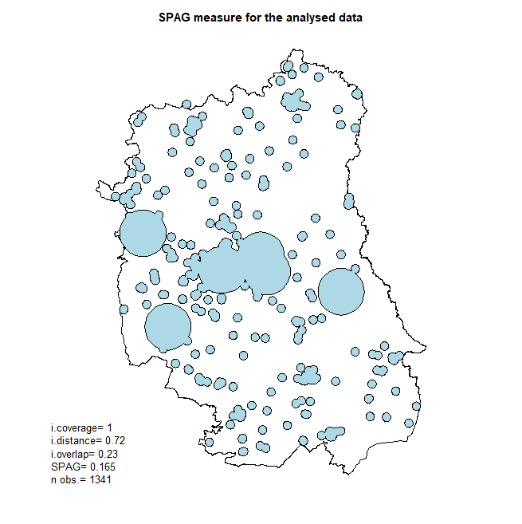

i=15
sec<-sectors[i] # select sector name
my.SPAG<-SPAG(firms.sf[firms.sf$SEC_PKD7==sec,], "empl", region.voi)

i=7
sec<-sectors[i] # select sector name
my.SPAG<-SPAG(firms.sf[firms.sf$SEC_PKD7==sec,], "empl", region.voi)

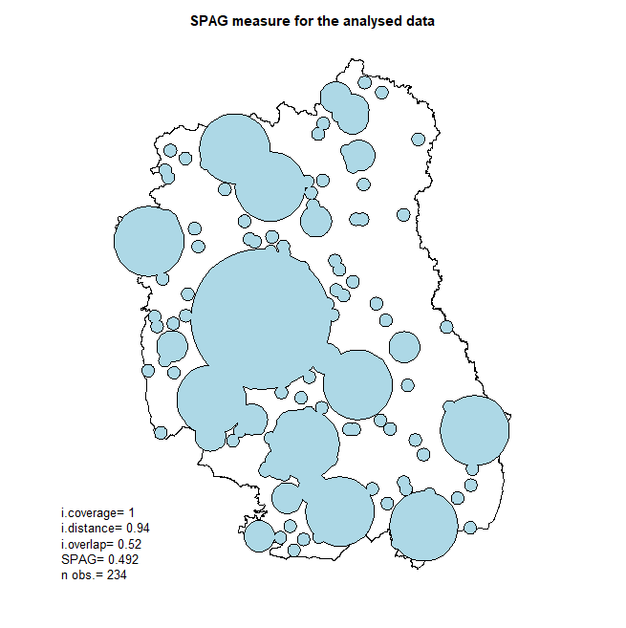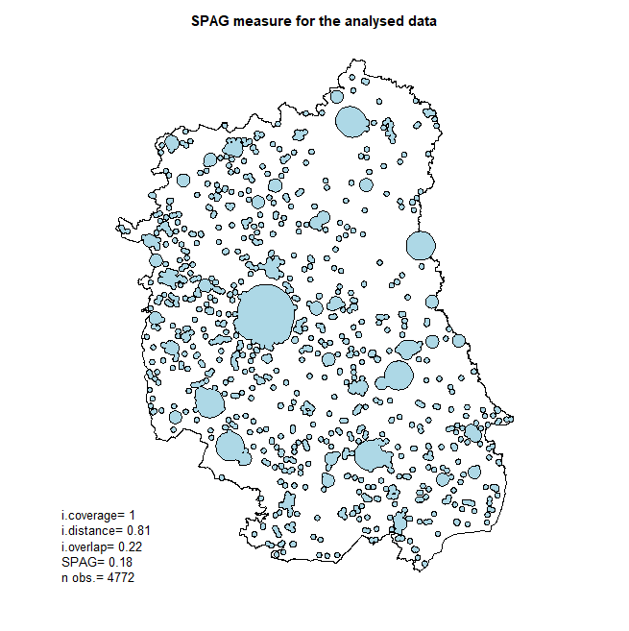

https://en.wikipedia.org/wiki/Entropy_(information_theory)

